Lesson 7 Circular string art

# Learning goal

Apply knowledge of arrays, loops and trigonometry to draw a circular string art pattern.

# Agenda

1. Draw the circular string art pattern on paper
2. Identify the input and output of the algorithm for drawing the pattern
3. Deriving formulas for the nails’ coordinates using trigonometry
4. Challenge 1: Teams of 2 derive the main for-loop on paper or on mini-whiteboards
5. Take up solution using Python broadcast
6. How can we store the nails’ coordinates in the 1st for-loop so that the next loop can use them to draw the lines without having to recalculate the coordinates for each pair of nails?
7. Challenge 2: Code the 2nd for-loop, which draws the lines.

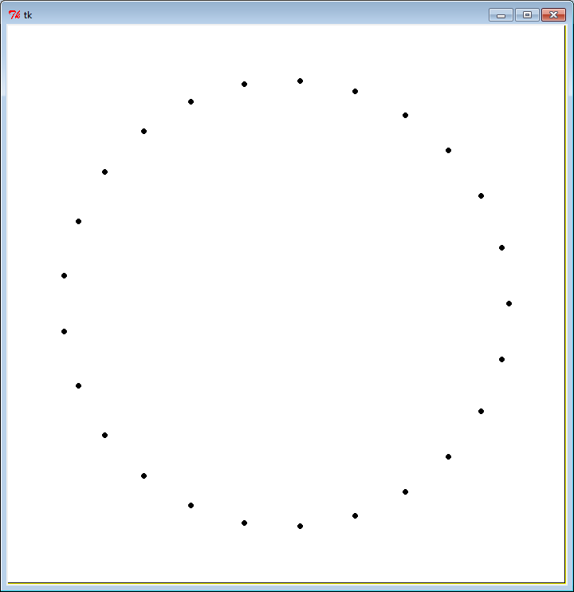

## Input and output of the algorithm

|  |  |
| --- | --- |
| **Input**:  n = number of nails  r = radius of big circle  (xc, yc) = centre of circle  s = number of nails to skip | **Output**:   1. *n* nails drawn evenly spaced along the edge of a circle of radius *r* and centre (*xc, yc*) 2. *n* lines drawn between each nail and the nail that is *s* nails clockwise from it. |

## Deriving formulas for the nails’ coordinates using trig